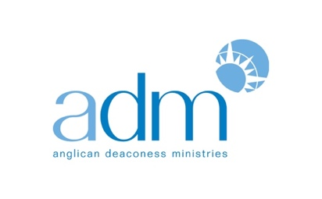

Re-Imagining Australia:
ADM’s Annual Lecture to Host Award-Winning Historian Meredith Lake

FOR IMMEDIATE RELEASE
22 October 2018
MEDIA CONTACT: Jo Kadlecek
JoKadlecek@deaconessministries.org.au
Mobile: 0456-502-121

Sydney—In a society that seems increasingly polarized, can understanding history play a role in shaping our future? Which stories of our shared past could enhance our current civic discourse?

These questions comprise the focus of ADM’s Annual Public Lecture, “Beautiful Lies? History, Religion and Our Common Life” featuring historian Dr. Meredith Lake. Dr. Lake’s lecture—which will take place at 7:30pm, Thursday, 8 November 2018, at St Andrew’s Cathedral in Sydney—will explore how stories from our history might help us reimagine Australia today.

A 2017 ADM Senior Research Fellow, Dr. Lake will draw in part from the award winning book she completed during her Fellowship, “The Bible in Australia: A Cultural History”(NewSouth: April 2018) to discuss the enormous power of stories in this era of ‘fake’ news and tribal politics.

“I’ve been concerned lately about the way our public conversations have been happening. We’re facing enormous issues, from the future of our common home to the way we do family life and the ways we deal with political and cultural differences,” Dr. Lake said. “What often happens when these issues are debated is that people, in their outrage, don’t listen to each other. We need a language and a sense of stories to address these issues as neighbours that can bring us together.”

With research interests in the social and cultural aspects of religion, Dr. Lake is an Honorary Associate of the Department of History, University of Sydney, whose primary focus ison how stories affect our common life. Her lecture reinforces ADM’s commitment to fostering rigorous and thoughtful discussion around Christian themes in the public square, and is co-sponsored by the Centre for Public Christianity.

“ADM’s Annual Public Lecture provides a platform for Christian women who demonstrate outstanding talent and leadership in their field, and who model a distinctive approach to Christian public engagement,” said Dr. Annette Pierdziwol, ADM’s Director of Public Engagement. “In past years we’ve hosted international speakers, but in 2018 we’re delighted to have one of our own alumna Dr. Meredith Lake give the Lecture and explore such a crucial topic for us today.”

At a Glance:
ADM Annual Public Lecture, co-sponsored by the Centre for Public Christianity: “Beautiful Lies? History, Religion and Our Common Life”, an evening with historian Meredith Lake
Date: Thursday, 8 November, 2018
Time: 7:30pm
Location: St Andrew’s Cathedral,Corner of George & Bathurst Streets, Sydney NSW 2000
For more information or to book tickets: http://www.deaconessministries.org.au/annual-public-lecture/

For media inquiries or interview requests, please contact JoKadlecek@deaconessministries.org.au.

